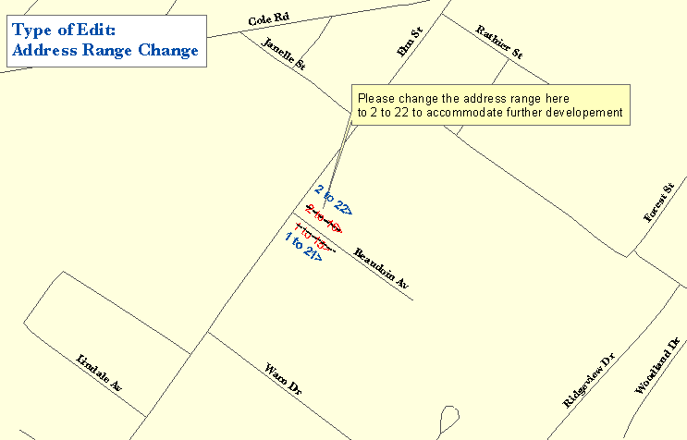

One Maine Enhanced 9-1-1 Update Form will need to be filled out for the above edit. The following sections are found on MSAG Update Forms and serves as an example as to what information needs to be provided to MEGIS in order to complete the edit. In addition, please provide all the information noted on the map above by marking it on a copy of the map book page. Please submit both the map book page and the Update Form to Emergency Services Communications Bureau/GIS.

FORM 1

- □ E. Address Range Change | Effective Date: 1/24/2003
Street Name: Beaudoin Av
Reverse direction of numbering | Reverse odds/evens
Number range change: ___Odds ___ Evens _ x__Both
Old range: low _1_ high_15__
New range: low _1_ high_22__

Remarks: Additional buildings were constructed

